Ali Oraiqat, 22110084
Machine Learning
Supervised by Dr.Ahmed Bataineh

Table of Contents
Part 1 and Part 2 1
Question 1 in the template) 1
Question 2 in the template) 2
Question 3 in the template) 5
Question 4 in the template) 8
Question 5 in the template) 10
Question 6 in the template) 13
Question 7 in the template): 14
Question 8 in the template) 16
Question 9 in the template) 20
Question 10 in the template) 22
Question 11 in the template) 26
Question 12 in the template) 28
PART-3 in template: 30
PART-4 in template: 33
PART-5 in template: 37

Part 1 and Part 2
Question 1 in the template)

A dataset of 1,000 patients is collected, including their age, weight, blood pressure, cholesterol level, and whether they developed heart disease within 5 years. The aim is to identify the factors most strongly associated with heart disease.
• Problem type: Classification (target is binary: developed heart disease yes/no, this is a problem that has discrete/binary outcomes ‘yes/no’, ‘0,1’, so we use classification because regression is used on continous values not discrete).
• Goal: Inference (the aim is to understand which factors — age, weight, BP, cholesterol are associated with the outcome, not just to predict).
• n: 1,000 patients (observations).
• p: 4 features (age, weight, blood pressure, cholesterol).

A real estate company records the sale prices of 5000 houses along with square footage, number of bedrooms, age of the property, and location rating, and wants to estimate the price of a newly listed house.
• Problem type: Regression (target is numeric: house sale price, we use regression for continous values, the target here is numeric and varies a lot, there are no discrete outcomes or options, hence why regression here is more suitable than classification).
• Goal: Prediction (goal is to estimate the price of a new house, not to analyze which factors matter most).
• n: 5,000 houses (observations).
• p: 4 features (square footage, number of bedrooms, age, location rating).

A dataset spanning five years since 2020 tracks the daily number of active users for an app, the total time spent on the application, peak usage hours during the day, and the most in-demand app features. The startup aims to forecast the number of active users and the total time spent on the application for the upcoming month.
• Problem type: Regression (targets are numeric: number of active users, total time spent, we use regression for continous values, the target here is numeric and varies a lot, there are no discrete outcomes or options, hence why regression here is more suitable than classification).
• Goal: Prediction (goal is to forecast future values, not explain relationships).
• n: 1,825 days (5 years of daily records, observations).
• p: 4 features (daily active users, time spent, peak usage hours, top features)

Question 2 in the template)
- Detect tumors in MRI scans.
Learning type: Supervised (the scans can be labeled as tumor or no tumor, there is a ‘label’, that’s why we pick supervised not unsupervised).
Algorithm: Convolutional Neural Networks (CNNs) can work best for MRI images because they are designed to handle pixels and patterns in pictures. A simpler option can be an SVM, but in that case, we usually need to first extract features from the scans, like shapes, textures, or intensity values, before training.
Time complexity:
- CNNs: Training can take about O(n × p × epochs), where n is the number of scans, p is the number of features (pixels), and epochs are the training rounds. This means training gets slower when we have more scans, larger images, or train for more passes.
- SVMs: Training can take about O(n² × p) or even worse for large datasets. This means if the dataset has many scans, training can become very slow.
Why ML is needed: MRI scans are very large and detailed, often with millions of pixels. The differences between healthy tissue and tumor tissue can be very small and not easy for doctors to see with the naked eye. On top of that, every patient’s scan can look slightly different depending on age, body type, or even the machine used. Simple rules cannot cover all these variations. Machine learning can learn from thousands of past scans, find the hidden patterns, and help detect tumors earlier and more accurately. This can reduce human error, save doctors time, and support better and faster medical decisions.

- Classify skin lesions into benign or malignant categories.
Learning type: Supervised (we have labels that tell us if a lesion is benign or malignant).
Algorithms: Logistic Regression or Decision Trees can be good simple starting points. If stronger performance is needed, we can use Random Forest or Gradient Boosting, since they combine multiple trees to get better accuracy.
Time complexity:
- Logistic Regression: Training is about O(n × p), where n is the number of samples and p is the number of features. This makes it quick and efficient even with larger datasets.
- Decision Tree: Training is about O(n × p × log n). This means it grows with the size of the dataset but still remains efficient.
- Random Forest: Training is about O(t × n × p × log n), where t is the number of trees. It is slower than a single tree because it builds many trees, but each tree by itself is still efficient.
Why ML is needed: Distinguishing between benign and malignant lesions can be very difficult, even for experienced doctors, because the differences are often subtle. Machine learning can learn from many labeled examples, pick up on details that may not be obvious to the human eye, and make the diagnosis more consistent and accurate. This reduces the chance of mistakes, helps doctors confirm their judgment, and improves early detection, which is critical for patient treatment.

- Group patients with similar genetic profiles for personalized treatment suggestions.
Learning type: Unsupervised (there are no labels; the goal is just to group patients based on genetic similarity).
Algorithms:
- K-means clustering: simple and effective for splitting patients into groups.
- Hierarchical clustering: useful for exploring how larger groups break down into smaller sub-groups.
Time complexity:
- K-means: Training is about O(n × k × i × p), where n is the number of patients, k is the number of clusters, i is the number of iterations, and p is the number of features (genes).
- Hierarchical clustering: Training can be about O(n² × p) or even O(n³) depending on the method, since it needs to compare all pairs of patients. This makes it slower for very large datasets.
Why ML is needed: Genetic data is very large and full of complex patterns that humans cannot analyze easily. Machine learning can automatically discover hidden patient groups with similar genetic profiles. These groups can then be used to suggest personalized treatments, since patients with similar genetics often respond to similar therapies. This makes care more targeted, more effective, and helps doctors design treatment plans that are better suited to each individual.

- Predict the likelihood of a patient being readmitted to the hospital within 30 days.
Learning type: Supervised (we have past data that tells us whether each patient was readmitted or not).
Algorithms:
- Logistic Regression: simple and easy to interpret, good for identifying which factors influence readmission.
- Gradient Boosting: more complex but provides stronger predictive accuracy when performance is the main goal.

Time complexity:
- Logistic Regression: Training is about O(n × p), where n is the number of patients and p is the number of features (like age, medical history, or treatments). It is very fast and efficient.
- Gradient Boosting: Training is about O(t × n × log n), where t is the number of trees. It takes longer than logistic regression because it builds many trees step by step, but the results are usually more accurate.
Why ML is needed: The likelihood of hospital readmission depends on many factors that interact in complicated ways, such as age, previous illnesses, treatments received, and lifestyle. Simple fixed rules cannot capture all these relationships. Machine learning can learn from large amounts of past patient data, detect patterns, and give better predictions. This helps hospitals reduce readmissions, improve patient care, and save costs.
- Detect faulty readings from wearable medical devices.
Learning type: Usually unsupervised (when we don’t have labels for faulty cases). If labeled faulty readings are available, then supervised learning can also be used.
Algorithms:
- K-means clustering: can group normal readings together, and any readings that fall far from these groups can be flagged as unusual.
- Statistical thresholds (like Z-scores): a simple method where readings that are too far from the normal range are treated as potential faults.
Time complexity:
- K-means: Training is about O(n × k × i × p), where n is the number of samples, k is the number of clusters, i is the number of iterations, and p is the number of features (sensor signals). This makes it efficient even with large datasets.
- Statistical thresholds: Training is basically just computing the mean and standard deviation, which is O(n × p), very fast.
Why ML is needed: Wearable devices produce a massive amount of continuous and often noisy data. Simple fixed thresholds may miss faulty readings or flag normal variations as errors. Machine learning can better understand what “normal” looks like by learning from patterns in the data and then spotting when something is unusual. This makes fault detection more accurate, reduces false alarms, and improves the reliability of wearable devices in real-world healthcare.

Question 3 in the template)
X1 | X2 | Label
7 | 6 | -1
8 | 5 | -1
10 | 7 | 1
11 | 8 | 1

The SVM (Support Vector Machine) is a supervised learning method that tries to find the best line (hyperplane) to separate two classes. The line is written as:
w⋅x+b=0
where w=(w1,w2) are the weights, and bb is the bias. The support vectors are the closest points to the boundary, and the SVM makes sure they satisfy the rule:
yi(w⋅x+b)=1

Step 1: Identify the support vectors
Looking at the dataset:
• Class −1: A = (7,6), B = (8,5)
• Class +1: C = (10,7), D = (11,8)
Because three points lie on the margin, take A = (7,6) and B = (8,5) from class −1 and C = (10,7) from class +1 as the support vectors.
Step 2: Write equations for support vectors
For support vector (10,7) with label +1:
w⋅(10,7)+b=+1
For support vector (8,5) with label -1:
w⋅(8,5)+b=−1
For support vector (7,6) with label -1:
w⋅(7,6)+b=−1
Step 3: Expand into equations
From (10,7):
10w1+7w2+b=1
From (8,5):
8w1+5w2+b=−1
From (7,6):
7w1+6w2+b=−1
Step 4: Subtract to eliminate bb
(10w1−8w1)+(7w2−5w2)=1−(−1)
2w1+2w2=2
w1+w2=1
Also subtract the two −1-margin equations to eliminate b again:
(8w1−7w1)+(5w2−6w2)=−1−(−1)
w1−w2=0
Step 5: Solve for bb
From w1−w2=0 we get w1=w2. Combined with w1+w2=1 gives w1=w2=0.5.
Use (8,5):
8(0.5)+5(0.5)+b= −1
6.5+b=−1
b=−7.5
Step 6: Choose a solution
Any (w1,w2,b) that satisfies these works. With w1=0.5, we have:
w2=0.5
b=−7.5
So one valid solution is:
w=(0.5,0.5), b= −7.5
Step 7: Verify with other points
For (7,6), label -1:
0.5(7)+0.5(6)−7.5= −1
For (11,8), label +1:
0.5(11)+0.5(8)−7.5=2 ≥ 1

The margins touch the closest points from each class. Here the model treats x and y equally, so you can just add them to see who’s closest. A: 7+6=13, B: 8+5=13, C: 10+7=17, D: 11+8=19. For the negative class, A and B tie as closest (13), so both sit on one margin. For the positive class, C is the closest (17), so it sits on the other margin. D is farther (19), so it’s not on a margin. That’s why three points (A, B, C) are on the margins.

To wrap up, we used three support vectors A(7,6) and B(8,5) from class −1, and C(10,7) from class +1. We wrote the margin equations they must satisfy (w·A+b = −1, w·B+b = −1, w·C+b = +1) and solved them, giving w = (0.5, 0.5) and b = −7.5. That’s the decision line 0.5x₁ + 0.5x₂ − 7.5 = 0 — the same as x₁ + x₂ = 15. The exact scale of w doesn’t matter, if you multiply w and b by the same number, the line doesn’t move. What matters is the direction of w and that these support vectors sit on the margins and pin the boundary in place.

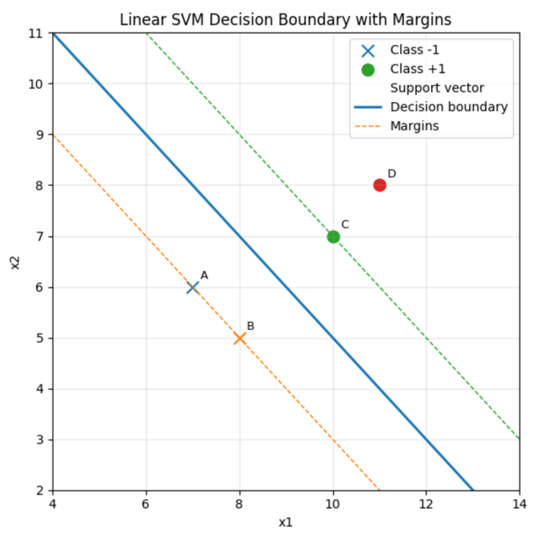

This plot shows the SVM split. The X marks are class −1 (A and B); the circles are class +1 (C and D). The solid line is the decision boundary x1+x2=15x1​+x2​=15. The dashed lines are the margins x1+x2=13x1​+x2​=13 and x1+x2=17x1​+x2​=17. A, B, and C are the support vectors they touch the margins and pin the boundary in place. D is on the correct side but not on a margin. In short, the SVM picks the straight line that separates the classes with the widest gap.

Question 4 in the template)
In logistic regresion, the sigmoid functon is applied to turn any real number into somthing between 0 and 1. This makes it helpfull for binary classificatoin tasks, where the model is trying to estimate the probability of an input belonging to one of two categories. The number that comes out of the sigmoid can be understod directly as the chance of the “positive” class. For instance, in medical prediction situations like stroke detection, a sigmoid score near 1 might mean a high likeliness of stroke, while a score close to 0 might mean very small probability.
However, the sigmoid function has some limitations when dealing with multi-class classification. If there are more than two classes, using only the sigmoid would give multiple probability values that do not necessarily add up to 1. To properly handle multi-class problems, we use the softmax function, which is an extension of the sigmoid. The softmax ensures that the outputs are valid probabilities across all classes by making them non-negative and summing to 1.
The main advantage of using sigmoid in logistic regression is its simplicity and clear interpretation in binary classification tasks. But in multi-class settings, softmax is preferred because it handles multiple outcomes correctly. This is why in your slides logistic regression is introduced with the sigmoid for two-class problems, while extensions like softmax or one vs rest logistic regression are used for more than two classes.
It’s important to note that the sigmoid function by itself does not allow proper multi-class classification. Sigmoid only works for binary problems, where there are just two possible outcomes. For cases with more than two classes, we need to extend the idea by using external resources and approaches/methods. These methods make sure that probabilities across all classes are valid and add up to 1, something sigmoid alone cannot guarantee.
The sigmoid is also easy to use because it smoothly changes between 0 and 1, but one drawback is that it can be slow to adjust when the input values are very large or very small. In those cases, the output is pushed close to 0 or 1 and the model learns more slowly. Even with this limitation, sigmoid is still the standard choice for binary logistic regression because it gives a clear and simple way to understand probabilities.

Example of how sigmoid function allows model to perform multiclass classification in logistic regression:

Sigmoid(x)= e^(wx+b)/1+e^(wx+b)
w= 2
b= 1.5

(This data is all based on assumption and hypothetical just to provide an example)

Sigmoid(3)= e^(2(3)+1.5)/ 1+e^(2(3)+1.5)
Sigmoid(3)= 0.999
Threshold= >0.5 = class 1 ; <0.5 = class 0
According to the threshold in this hypothetical case the probability of 0.999 shows that it falls in class 1.

Question 5 in the template)
BMI | Blood pressure | Family History (Heart Disease) | Stroke
N | N | N | N
L | H | Y | N
L | H | Y | N
H | H | N | Y
H | N | N | Y
N | N | Y | N
H | N | Y | Y
L | H | N | Y
L | H | N | Y
N | N | N | N

Total instances: 10
Target class distribution:
• Stroke = Y: 5 instances
• Stroke = N: 5 instances
Step 1: Calculate Root Entropy
Entropy formula: Entropy(S) = -Σ p(i) × log₂(p(i))
For the root node:
• P(Stroke = Y) = 5/10 = 0.5
• P(Stroke = N) = 5/10 = 0.5
Root Entropy = -(0.5 × log₂(0.5)) + (0.5 × log₂(0.5)) = -(0.5 × (-1)) + (0.5 × (-1)) = 0.5 + 0.5 = 1.0
Step 2: Calculate Information Gain for Each Feature
Feature 1: BMI
Value distributions:
• BMI = N: 3 instances (Stroke: Y=0, N=3) → Pure N
• BMI = L: 4 instances (Stroke: Y=2, N=2) → Mixed
• BMI = H: 3 instances (Stroke: Y=3, N=0) → Pure Y
Entropy calculations:
• Entropy(BMI = N) = 0
• Entropy(BMI = L) = 1.0
• Entropy(BMI = H) = 0
Weighted entropy: Entropy(S|BMI) = (3/10 × 0) + (4/10 × 1.0) + (3/10 × 0) = 0.4
Information Gain(BMI) = 1.0 − 0.4 = 0.6
Feature 2: Blood Pressure
Value distributions (corrected counts):
• BP = N: 5 instances (Stroke: Y=2, N=3) → Mixed
• BP = H: 5 instances (Stroke: Y=3, N=2) → Mixed
Entropy calculations:
• Entropy(BP = N) = −(2/5 × log₂(2/5)) + (3/5 × log₂(3/5)) ≈ 0.971
• Entropy(BP = H) = −(3/5 × log₂(3/5)) +(2/5 × log₂(2/5)) ≈ 0.971
Weighted entropy: Entropy(S|BP) = (5/10 × 0.971) + (5/10 × 0.971) = 0.971
Information Gain(BP) = 1.0 − 0.971 = 0.029
Feature 3: Family History
Value distributions (corrected counts):
• FH = N: 6 instances (Stroke: Y=4, N=2) → Mixed
• FH = Y: 4 instances (Stroke: Y=1, N=3) → Mixed
Entropy calculations:
• Entropy(FH = N) = −(4/6 × log₂(4/6)) + (2/6 × log₂(2/6)) ≈ 0.918
• Entropy(FH = Y) = −(1/4 × log₂(1/4)) + (3/4 × log₂(3/4)) ≈ 0.811
Weighted entropy: Entropy(S|FH) = (6/10 × 0.918) + (4/10 × 0.811) ≈ 0.875
Information Gain(FH) = 1.0 − 0.875 = 0.125
Step 3: Information Gain Summary
Feature Information Gain
BMI 0.6
Blood Pressure 0.029
Family History 0.125
BMI has the highest information gain (0.6), so it becomes the root node.
Step 4: Decision Tree Construction
Root Node: BMI
The tree splits on BMI with three branches:
• BMI = N → Stroke = N (pure, 3 instances)
• BMI = H → Stroke = Y (pure, 3 instances)
• BMI = L → Mixed (4 instances: Y=2, N=2) – needs further splitting
Splitting BMI = L subset
For the 4 instances where BMI = L:
• (L, H, Y, N)
• (L, H, Y, N)
• (L, H, N, Y)
• (L, H, N, Y)
Blood Pressure for BMI=L subset:
• BP = H: 4 instances (all BMI=L have BP=H)
• No split possible, Information Gain = 0
Family History for BMI=L subset:
• FH = Y: 2 instances (Stroke: Y=0, N=2) → Pure N
• FH = N: 2 instances (Stroke: Y=2, N=0) → Pure Y
This gives perfect classification, so Family History is chosen for the BMI=L branch.

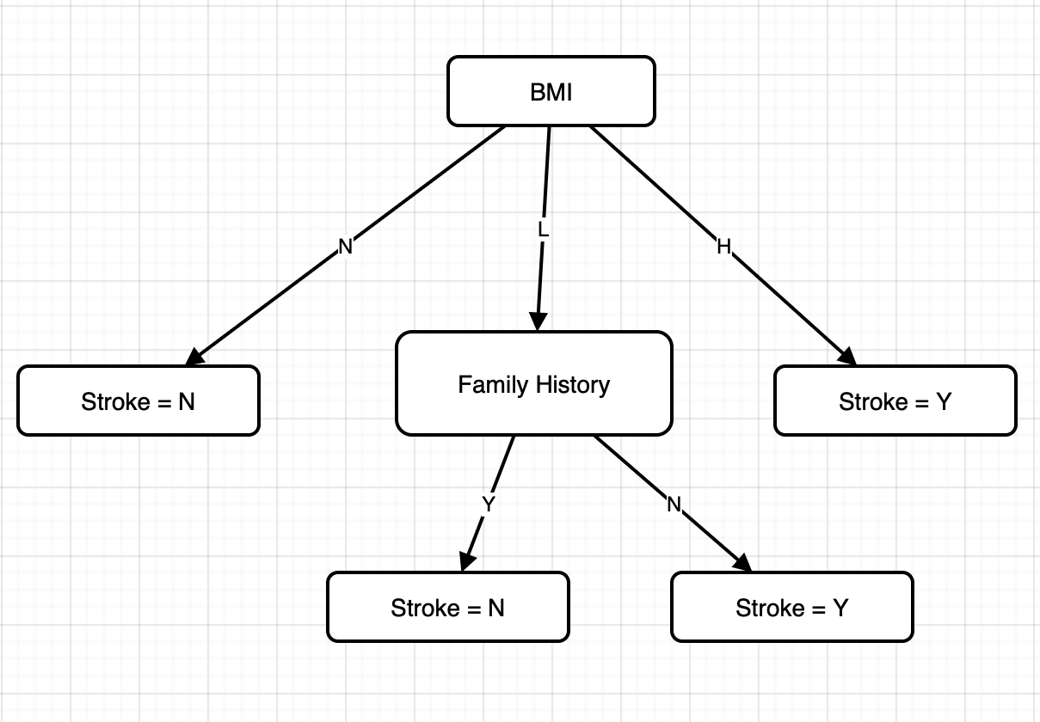
Final Decision Tree

Decision Rules
- If BMI = N → Stroke = N
- If BMI = H → Stroke = Y
- If BMI = L and Family History = Y → Stroke = N
- If BMI = L and Family History = N → Stroke = Y

Question 6 in the template)

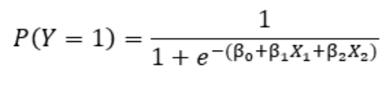
- Estimate the probability of passing for a student who studies 50 hours and takes 4 practice exams.

Before i get started with the calculations id like to explain the steps im about to do:
-Initialize or determine given values
-Replace these values inside the probability equation attached (one i attached)
-Solve the equation

x1 = 50
x2 = 4
p(y)=1/1+ e^{-(-4 + 0.04*50 + 0.6*4)}

^{p(y)= 0.5987}

- Find the minimum number of practice exams needed for a student who studies 30 hours to have at least a 70% chance of passing.

Now for this 2nd part i want to explain that the probbaility is given so i want to solve for amount of practice exams needed which is X2, so ill replace all given values like i did above but this time ill solve for X2 instead of Y since Y(probability) is already given.

0.7 = 1/1+e^{-(-4 + (0.04*30) + (0.6 * X2))}
0.7 = 1/1+e^{-(-4 + (1.2) + (0.6 * X2))}
0.7 = 1/1+e^{-(-2.8+ (0.6 * X2))}
1/0.7 = 1+e^{-(2.8 + (0.6 * X2))}
1/0.7-1 = e^{-(2.8 + (0.6 * X2))}
0.4286 = e^{-(2.8 + (0.6 * X2))}
-(0.6X2-2.8) = ln(0.4286)

(Final step done on calculator directly, solving for X2)

^{X2=6.08}
Since exams must be whole the minimum is 6 practice exams

Question 7 in the template):
Consider a simple regression problem with the following data:
Instance | True Value
1 | 10
2 | 15
3 | 20

Learning rate=0.1
F0=12 for all the instances
1)
Compute the residuals:
Initial prediction f0=12
• Instance 1: r1(0)=10−12= -2
• Instance 2: r2(0)=15−12= 3
• Instance 3: r3(0)=20−12= 8

2)
Mean of residuals: -2+3+8/3 = 3
Now we update the model with the learning rate which is 0.1
f1​(x)=f0​(x)+η⋅mean​=12+0.1×3​= 12.3
f1=12.3
After first weak learner
-weak learner prediction h0= 3
-updated model f1(x)=12.3

3)
Now we compute the new residuals using f1(x) =12.3
ri(1)​=yi​−f1​(xi​)
• Instance 1: 10−12.3= -2.3
• Instance 2: 15−12.3= 2.7
• Instance 3: 20−12.3= 7.7
4)
Now we find the mean of the new residuals:
h1=-2.3+2.7+7.7/3 = 2.7
f2​(x)=f1​(x)+η⋅h1​=12.3+0.1×2.7
f2= 12.57​

Interpretation
Here’s how the algorithm improves:
- At the start, all predictions were fixed at 12, which was too low for most points.
- The first weak learner corrected in the right direction by adding a small step (learning rate × mean residual = 0.3). Predictions moved up to 12.3.
- The second weak learner added another smaller step (0.27), pushing predictions up to 12.57.
- With each iteration, the model keeps adjusting slightly towards the true values. Instead of jumping directly, gradient boosting makes small corrections, reducing errors stage by stage.

In this solution, I worked through a very basic version of gradient boosting step by step. I began with one starting prediction for every point, which was 12, and then measured the errors (residuals) by checking how far those predictions were from the true values. These residuals showed me the direction in which the model needed to adjust. Instead of using complex models like decision trees, I used a very simple weak learner that just predicts the average of the residuals. With each round, I added a small correction to the model, controlled by the learning rate, so the updates were steady and not too big. After updating, I recalculated the residuals again, fitted another weak learner to them, and made another small correction. This repeating process is the core idea of gradient boosting: the model keeps learning from its mistakes, shrinking the errors little by little until the predictions move closer to the actual values. This shows how gradient boosting improves predictions gradually, by fixing a little bit of the error at each step instead of trying to correct everything all at once.

Question 8 in the template)

Actual | S | S | S | S | S | S | S | S | S | S | S | S | S | S | S | S | S | S | S | S | S | S | S | S | S
Predicted | S | S | S | S | S | S | S | S | N | S | S | N | S | S | S | S | S | S | S | S | S | S | S | S | S

Actual | N | N | N | N | N | N | N | N | N | N | N | N | N | N | N | N | N | N | N | N | N | N | N | N | N
Predicted | S | S | N | S | N | N | N | S | N | N | N | N | S | N | N | S | N | N | N | N | N | N | N | N | N

TP=true positive
TN=true negative
FP=false positive
FN=false negative

Application A
Total emails= 50 (25 spam , 25 non-spam)
Recall= 0.76 , F1= 0.824

Step 1 is finding the recall (TPR)=

TPR= TP/TP+FN =0.76

Because TP+FN= 25 we have
TP=0.76 x25
TP=19

Step 2 is finding the precision (from the f1 score):

F1= 2 x P x R/ P+R
0.824=2xPx0.76/P+0.76
P (which is precision)= 0.90

Step 3 now which is finding the false positives and True negative TN:

P=TP/TP+FP from this we can dictate that FP is:

FP= TP/P – TP = 19/0.90 – 19 = 2
FP=2

TN=25-FP(which is 2)
TN=23

TPR= 19/25 =0.76
FPR= 2/25 =0.08

Application B

Recall=0.88
Precision=0.84

Step 1 is finding the TP and FN

TP=0.88 x 25
TP=22
FN= 25-TP(which is 22)
FN=3

Step 2 is finding the false positives FP

FP=TP/P-TP
FP=22/0.84-22
FP=4

TN=25-FP(which is 4)
TN=21

TPR= 22/25 =0.88
FPR= 4/25 =0.16

Application C
Given (from the tables):
- Total spam (positive) emails = 25
- Total non-spam (negative) emails = 25
1) Finding TP,TN,FP,Fn
Spam section (actual = spam):
23 spam,2 non spam
TP=23
FN=2
Non-spam section (actual = non-spam):
5 spam, 20 non spam
FP=5
TN=20

TPR=TP/TP+FN=23/25=0.92
FPR=FP/FP+TN=5/25=0.2

Here are the confusion matrices which help us summarize the predictions and show which one is correct and which one isnt per class.

Application A confusion matrix | Prediced Spam (positive) | Predicted Non Spam (negative)
Actual Spam (positive) | TP=19 | FN=6
Actual Non-spam (negative) | FP=2 | TN=23

Application B confusion matrix | Prediced Spam (positive) | Predicted Non Spam (negative)
Actual Spam (positive) | TP=22 | FN=3
Actual Non-spam (negative) | FP=4 | TN=21

Application C confusion matrix | Prediced Spam (positive) | Predicted Non Spam (negative)
Actual Spam (positive) | TP=23 | FN=2
Actual Non-spam (negative) | FP=5 | TN=20

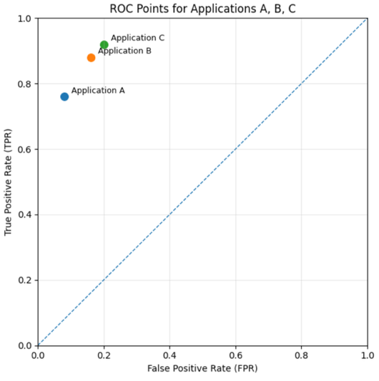
Before i decsribe how a ROC could be more insightful than a confusion matrix , first i want to explain what ROC is. The ROC is graphical tool used to evaluate the performance of a binary classification model by plotting the true positive rate (sensitivity) against the false positive rate (1 - specificity) at various threshold settings. On an ROC curve (x-axis = FPR, y-axis = TPR), the three apps plot at: A (0.08, 0.76), B (0.16, 0.88), and C (0.20, 0.92). App A sits more to the left (fewer false alarms) but lower; B is higher and a bit to the right; C is highest but farthest to the right. ROC analysis is more informative than a confusion matrix when you care about all possible thresholds rather than one fixed threshold: it shows the trade-off between catching spam (higher TPR) and flagging good mail (higher FPR), helps you choose an operating point that matches your error costs, and supports fair model comparison (e.g., with AUC), including when classes are imbalanced.

Question 9 in the template)
Underfitting is when the model is too simple and cannot learn the main patterns in the data. During evaluation, the key sign is that both the training accuracy and the validation/test accuracy are low. This means the model is not performing well on the data it has seen or on new data. Underfitting often happens when the model is not complex enough for the task, when too few features are used, or when training is stopped too early.
When a model is underfitting, it is basically failing to capture the structure of the data. For example, using a straight line to fit data that clearly follows a curve will give bad results, because the line is too simple to reflect the real relationship. Another common sign is that even if you train the model longer, the accuracy does not improve much, because the model itself is too weak to represent the data. Learning curves for underfitting usually show both training and validation accuracy staying low and close together, which means the model never really learns the signal. Underfitting can also happen when important variables are missing, so the model has no way to “see” the information it needs, or when the regularization is set too strong and forces the model to stay overly simple. The effect of underfitting is that the model makes poor predictions everywhere it doesn’t just fail on new data, it also fails on the data it already saw. In practice, this tells us we need to increase model capacity, provide more useful features, or reduce the restrictions we placed on the model so it can learn more flexible patterns.
To reduce underfitting, common techniques are:
- Use a more complex model, for example moving from linear regression to decision trees or random forests.
- Add more useful features that provide additional information for the model to learn from.
- Train for longer or reduce regularization so the model has more freedom to capture the underlying patterns.
- Tune hyperparameters better, like adjusting learning rate or kernel settings, so the model can fit the data more closely.
- Combine models using ensemble methods (like boosting), which can capture more complex patterns than a single simple model.

Overfitting is the opposite problem, where the model becomes too complex and starts memorizing the training data instead of learning general rules. The main sign during evaluation is that the training accuracy is very high but the validation/test accuracy is much lower. This gap shows the model is not generalizing well. Overfitting is often caused by using overly complex models (like very deep decision trees), training with too little data, or training without regularization to keep the model in check.
When a model is overfitting, it is basically learning the noise and random details of the training data instead of just the important patterns. A clear example is when a decision tree is allowed to grow too deep it can perfectly classify the training points but then fails badly when shown new points because the “rules” it learned are too specific. Learning curves for overfitting usually show the training accuracy going up and staying near perfect, while the validation accuracy stops improving, levels off, or even gets worse as training continues. Another sign is that the model predictions can be unstable: a small change in the training data may cause a big change in the model. Overfitting is more likely when there is too little training data, when the dataset is noisy, or when the model is so flexible that it can twist itself to fit everything. The effect of overfitting is that the model looks very strong during training but gives disappointing results in real use, since it has not actually learned general rules. To handle overfitting, we often simplify the model, add regularization to control its complexity, use more data or data augmentation, or apply techniques like early stopping and cross-validation to make sure the model doesn’t just memorize but actually learns to generalize.
To mitigate overfitting, useful techniques include:
- Simplify the model, for example by pruning or limiting the depth of a decision tree.
- Add regularization, such as Ridge or Lasso for regression, or tuning the C parameter in SVMs to control complexity.
- Use more data or apply cross-validation/early stopping to ensure the model focuses on general patterns rather than memorizing noise.
- Use data augmentation, especially for images or text, to create more variety without collecting new data.
- Apply ensemble methods like bagging or random forests, which combine multiple models to reduce variance and smooth out overfitting.

In summary, underfitting happens when a model is too simple and ends up with low accuracy on both the training and test data. It shows that the model has not learned the important patterns at all. Overfitting is the opposite the model looks great on training data but performs poorly on test data, creating a clear gap between the two scores. This means it has memorized details of the training set instead of learning general rules. The real goal in practice is to find the right balance between these two extremes. A good model should be complex enough to capture the real patterns in the data, but not so complex that it starts memorizing noise or irrelevant details. This balance is usually reached through careful choice of model type, regularization, feature selection, and evaluation techniques like cross-validation.

(causes, and signs are mentioned and highlighted in the paragraphs not in the bullet points)

Question 10 in the template)
Table 1: Training Data Set
quantity of items sold | wholesale prices | X^2 | x.y
5 | 26 | 25 | 130
8 | 38 | 64 | 304
6 | 30 | 36 | 180
11 | 50 | 121 | 550
7 | 34 | 49 | 238
12 | 54 | 144 | 648
4 | 22 | 16 | 88
9 | 42 | 81 | 378
13 | 58 | 169 | 754
3 | 18 | 9 | 54
14 | 62 | 196 | 868

To solve this problem, I will fit a simple linear regression model that predicts the wholesale price of items based on the quantity sold. Regression is appropriate here because the target variable (price) is continuous, not categorical. The idea is to find the line of best fit, y^=b0+b1x, where b0​ is the intercept and b1b1​ is the slope. To calculate these, I first need to compute the basic sums (Σx, Σy, Σx², Σxy) from the training data, which will then allow me to calculate the slope and intercept using the least squares method. Once I have the equation of the line, I can use it to predict prices for the test quantities and then evaluate how accurate the predictions are.

-In this regression problem, the quantity of items sold is taken as the independent variable (x), and the wholesale price is the dependent variable (y), since the goal is to predict price based on quantity.

-Now i want to calculate:
- Σx → add all quantities
- Σy → add all wholesale prices
- Σx^2 → add all squared quantities
- Σ(x⋅y) → add all products of x and y
Σx= 5+8+6+11+7+12+4+9+13+3+14
Σx=92
Σy= 26+38+30+50+34+54+22+42+58+18+62
Σy=434
Σx^2= 25+64+36+121+49+144+16+81+169+9+196
Σx^2 =910
Σ(x⋅y)= 130+304+180+550+238+648+88+378+754+54+868
Σ(x⋅y)=4192

Now we calculate the means of x and y:
xˉ= Σx/n=92/11=8.36
yˉ​=Σy/n=434/11=39.45

Now i want to calculate the variation of x (Sxx) and covariation of x and y (Sxy) which is how they move together. I do this step because later ill need these values to find the slope of the regression line. (The denominator of the regression line slope formula in the slides)

• Sxx​= Σx2−n(xˉ)^2
• Sxy=Σ(x⋅y)−n(xˉyˉ)
Sxx= 910-11(8.36)^2
Sxx= 141.21
Sxy= 4192-11(8.36x39.45)
Sxy=564.18

Now with these values we compute the slope and intercept

• b1​=Sxy/Sxx
• b0=yˉ−b1xˉ
b1=3.995
b0= 39.45 – 3.995(8.36)
b0= 6.052

Now after all of this we finally have the regression line to use to find the predicted values, and plug them in table 2.
Regression line =y^​=6.05+3.995x
y^​=6.05+3.995(25)
y^​=6.05+3.995(83)
y^​=6.05+3.995(94)

Table 2: Testing Data Set
quantity of items sold | Predicted | Actual
25 | 105.93 | 108
83 | 337.64 | 335
94 | 381.58 | 370

Since the test set is very small, MAE is the best choice because it gives the average error in the same units (thousand JOD), while RMSE and R² are more useful with larger datasets.

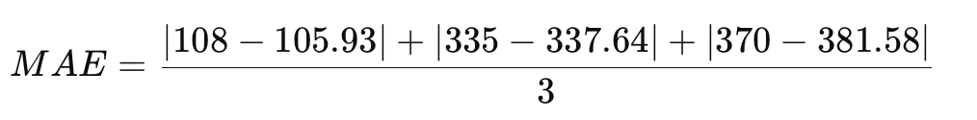

MAE=4.05

The Mean Absolute Error (MAE) is 4.05, which means that on average the model’s predictions differ from the actual wholesale prices by about 4.05 thousand JOD. This shows that the regression model gives very accurate predictions for the test data. MAE is a good choice of metric here because it is easy to interpret in the same units as the target variable, so we can directly understand how far off our predictions are in terms of money. A low MAE like 4.05 compared to the overall price range means the error is very small and the model is doing a strong job. It also shows that the line we fitted is capturing the main trend between quantity and price, rather than just memorizing the training data. If the error had been much larger, it would suggest the model is underfitting (too simple) or that the relationship between quantity and price is not linear. In this case, the results show that a linear relationship works well. With a bigger dataset, we might also use other metrics like RMSE (to penalize large mistakes more) or R² (to measure how much variance in price is explained by quantity), but for this small test set MAE is the most practical. Overall, the results suggest that linear regression is appropriate here and can be relied on for making price predictions when the quantity sold is known.

Question 11 in the template)
Observed | Predicted
2 | 1.8
3 | 3.1
5 | 4.9
7 | 6.8
8 | 8.0

Tasks:
- Calculate the mean of observed values.
- Compute SST, SSE, and R^2.
- Interpret R^2 in context.

Task 1:
Mean_observed_values= (2+3+5+7+8)/5
Mean_observed_values= 5

To find the mean, we just add up all the observed numbers (2, 3, 5, 7, and 8) and divide by how many there are. The total is 25, and dividing by 5 gives us 5. This number is the “average” of the data and shows the middle point around which the other values spread. We use this mean later when we measure how far the data points are from the center.

Task 2:

SST (Total Sum of Squares) measures the total variation of the observed values from their mean.
SST=∑(yi​−yˉ​)^2
Where yi= observed, and yˉ = mean
(2-5)^2+(3-5)^2+(5-5)^2+(7-5)^2+(8-5)^2
SST = 26

SSE (Sum of Squared Errors) measures how far the predicted values are from the observed values
SSE=∑(yi​−y^​i​)2
where yi​ = observed, and y^​ = predicted.
(2-1.8)^2+(3-3.1)^2+(5-4.9)^2+(7-6.8)^2+(8-8.0)^2
SSE= 0.1

R² (Coefficient of Determination) shows the proportion of the variation in the observed data that is explained by the model.
R^2=1−(SSE/SST​)
Where SST is Total sum of squares, and SSE is sum of squared errors.
1-(0.1/26)
R^2=0.9962

SST is the total variation in the data. It tells us how much the observed values move away from the average of 5. We worked it out and got 26, which is the overall spread of the data. SSE is the error of the model it shows how far the predictions are from the actual observed values. The smaller it is, the better the predictions. Here, SSE is only 0.1, which is very small. Finally, R² compares these two numbers and shows how much of the variation is explained by the model. Our R² is 0.9962, which means the model explains almost everything in the data.

Task 3:

The model explains 99.62% of the variation in the observed values. This means the regression model provides an excellent fit, as the predictions are very close to the actual observations. In other words, almost all of the differences we see in the observed data can be accounted for by the model’s predictions. Only 0.38% of the variation is left unexplained, which is very small. This tells us that the model is very reliable for this dataset, and the errors between predicted and observed values are minimal.

This also means that if we were to use this model for making future predictions, we could trust it to be very accurate, since it already matches the current data so well. A model with such a high R² value is rare, and usually shows that the relationship between the variables is very strong and almost perfectly linear. Of course, in larger or more complex datasets, we would not always expect an R² this high, but in this small example it shows the regression line fits the points almost exactly. The tiny errors we see could be due to rounding or natural randomness in the data, but overall the model captures the true pattern extremely well.

Question 12 in the template)
Model 1: Y=2+1X+1X^2
Model 2: Y=1+1.5X+0.5X^2+0.1X^3

X | Y
1 | 3
2 | 8
3 | 15
4 | 24
5 | 35

Computing prediction values for model 1:
Here i plugged in the values of X in the first model that they gave to us in the question.

X(1); Y=2+1(1) +1(1)^2 = 4
X(2); Y=2+1(2)+1(2)^2= 8
X(3); Y=2+1(3)+1(3)^2= 14
X(4); Y=2+1(4)+1(4)^2= 22
X(5); Y=2+1(5)+1(5)^2= 32

Computing prediction values for model 2:
Here i plugged in the values of X in the second model that they gave to us in the question.

X(1); Y=1+1.5(1)+0.5(1)^2+0.1(1)^3 = 3.1
X(2); Y=1+1.5(2)+0.5(2)^2+0.1(2)^3 = 6.8
X(3); Y=1+1.5(3)+0.5(3)^2+0.1(3)^3 = 12.7
X(4); Y=1+1.5(4)+0.5(4)^2+0.1(4)^3 = 21.4
X(5); Y=1+1.5(5)+0.5(5)^2+0.1(5)^3 = 33.5

X | Y | Predicted Y from model 1 | Predicted Y from model 2
1 | 3 | 4 | 3.1
2 | 8 | 8 | 6.8
3 | 15 | 14 | 12.7
4 | 24 | 22 | 21.4
5 | 35 | 32 | 33.5
Computing value of RSS for both models:

RSS=∑(Yobserved​−Ypredicted​)2
_
RSS_model1 = (3-4)^2+(8-8)^2+(15-14)^2+(24-22)^2+(35-32)^2
RSS_model1= 15

RSS_model2=(3-3.1)^2+(8-6.8)^2+(15-12.7)^2+(24-21.4)^2+(35-33.5)^2
RSS_model2= 15.75

Computing value of R^2 for both models:

R2=1−RSS/SST
SST=∑(Y_observed​−Yˉ)2

Y_mean=17
SST=(3-17)^2+(8-17)^2+(15-17)^2+(24-17)^2+(35-17)^2
SST= 654

R2_model1= 1-(15/654)
R2_model1= 0.9771

R2_model2 = 1-(15.75/654)
R2_model2= 0.9759

Interpretion:

Both models explain about 97–98% of the variation in the observed data, which shows that they both fit the dataset very well. Model 1 has a slightly lower RSS (15 vs. 15.75) and a slightly higher R² (0.977 vs. 0.976), so it provides the better fit overall.
Conclusion: Model 1 is preferred here, because it achieves a marginally better performance with a simpler form (quadratic vs. cubic). Simpler models are usually favored when they perform equally well or better, as they are easier to interpret and less prone to overfitting.
This means that both models can describe the relationship between X and Y quite accurately, but Model 1 does it with fewer terms and slightly better accuracy. Adding the cubic term in Model 2 did not improve the results and only made the equation more complicated. For this dataset, sticking with the simpler quadratic model is the better choice since it is clear, reliable, and already matches the data very well.

PART-3 in template:
Problem Statement
Heart disease is a major health concern worldwide, and early detection plays a crucial role in preventing severe outcomes and saving lives. The objective of this project is to design and develop a machine learning model that can predict whether a patient has heart disease, based on a variety of medical and demographic features. The goal is to use historical patient data to build a classifier that can generalize well and assist healthcare professionals in identifying patients at risk.
Requirements and Details
- Type of Problem
  - This is a binary classification problem, where the model assigns each patient to one of two categories:
    - Class 0: Patient does not have heart disease.
    - Class 1: Patient has heart disease.
- Dataset Characteristics
  - Number of records (rows): 1,025 (greater than 1,000, satisfying the requirement).
  - Number of features (columns): 14 (greater than 6, satisfying the requirement).
  - Feature examples: Age, sex, cholesterol level, resting blood pressure, maximum heart rate, fasting blood sugar, chest pain type, and more. These features capture both clinical measures and personal demographics.
- Input and Output
  - Input: A patient’s health attributes (the 14 features).
  - Output: A prediction of whether the patient is likely to have heart disease (0 = no disease, 1 = disease).
- Constraints
  - The dataset must be properly preprocessed before training, including handling missing values, encoding categorical variables, and scaling numerical attributes where needed.
  - The model should not only aim for high accuracy but also prioritize recall (sensitivity), because missing patients who actually have the disease (false negatives) is more harmful than false alarms.
  - The final model should balance predictive power with interpretability, since doctors must be able to understand and trust the predictions.
- Project Goal
  - To create a machine learning system that can reliably classify patients into “disease” or “no disease” groups using the given dataset.
  - To evaluate different algorithms and select the one that performs best in terms of accuracy, sensitivity, and generalization on unseen data.

2. Find the best ML algorithms used to train models for such a problem.

Best ML Algorithms for Heart Disease Prediction
Logistic Regression:
- Simple and easy to understand.
- Gives probabilities for each prediction.
- Works well when the data is fairly linear.
Decision Tree:
- Very easy to explain and visualize.
- Can handle both numbers and categories.
- Finds rules in the data directly.
Random Forest:
- A group of many decision trees combined.
- More accurate and less likely to overfit than a single tree.
- Can show which features are most important.
Support Vector Machine (SVM):
- Good at separating two classes with a clear boundary.
- Works well even when there are many features.
- Best for medium-sized datasets.

3.

Algorithm | Advantages | Disadvantages
Logistic Regression | Simple, easy to use, gives probabilities | May not work well if data is very complex
Decision Tree | Easy to explain and visualize, handles mixed data | Can overfit if tree gets too deep
Random Forest | More accurate than single tree, less overfitting | Slower to train, harder to explain fully
SVM | Good at clear separation, works with many features | Training can be slow on large datasets

Justification
Logistic Regression is simple and interpretable, so it’s useful as a starting point. Decision Tree is also simple and easy to explain but can overfit, which is why Random Forest is better since it combines many trees and is more stable.. SVM can work well, but it is slower and less interpretable for bigger data.
For this project, we will focus on four models:
- Logistic Regression (baseline, simple and clear)
- Decision Tree (easy to explain and visualize)
- Random Forest (better accuracy, less overfitting)
This way, we cover both simple and advanced models, and can compare them fairly.

PART-4 in template:
Model Development

1. Dataset Description
We are working with the Heart Disease Train-Test dataset.
- Size: 1,025 patient records.
- Features: 14 columns (like age, sex, cholesterol, blood pressure, chest pain type, max heart rate, etc.).
- Target: One column that shows if the patient has heart disease (1) or not (0).
- Domain: Healthcare.
- Why important: Heart disease is a big health problem. If we can predict it early using patient data, doctors can help patients faster and save lives.

2. Preprocessing & Splitting
Before training the models, we prepared the data:
- Checked and confirmed there are no missing values.
- Changed categorical values (like sex, chest pain type) into numbers using label encoding.
- Scaled the numerical values using StandardScaler so that features are on the same scale.
- Split the data:
  - 70% training
  - 15% validation
  - 15% testing

3. Training the Models
We trained four models:
- Logistic Regression :simple, gives probabilities, easy to explain.
- Decision Tree : makes rules, easy to draw and understand.
- Random Forest : uses many trees together, more stable and accurate.
- SVM : works by finding a hyperplane to seperate classes.
Each model was trained on the training data and tested on the validation set.

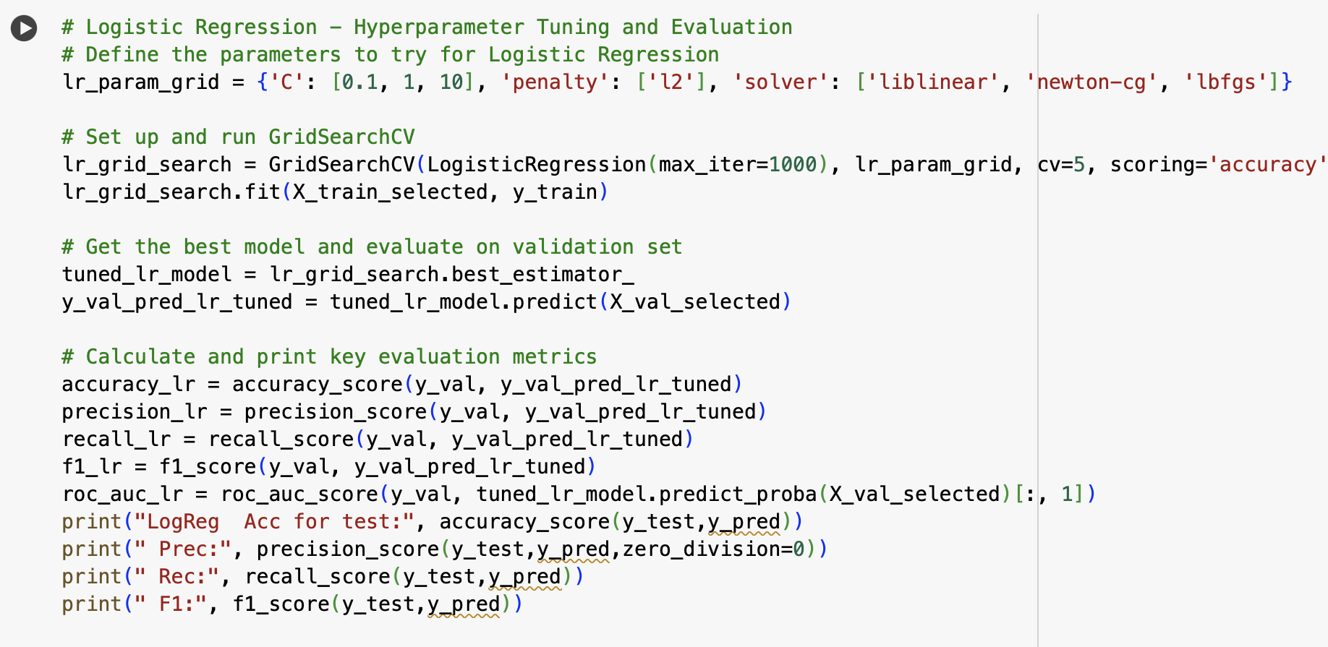
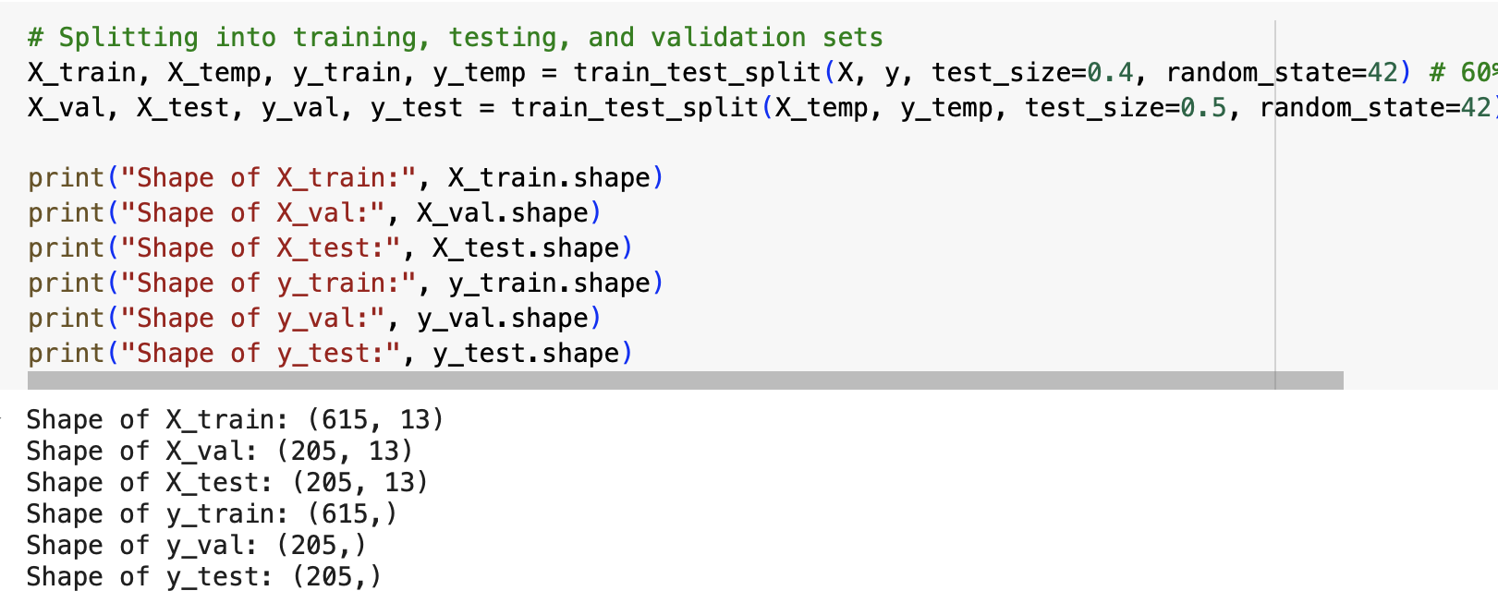

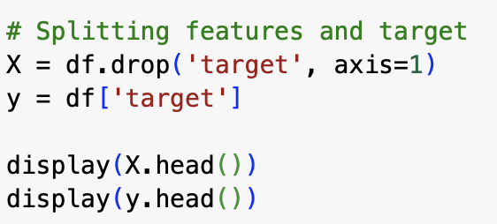

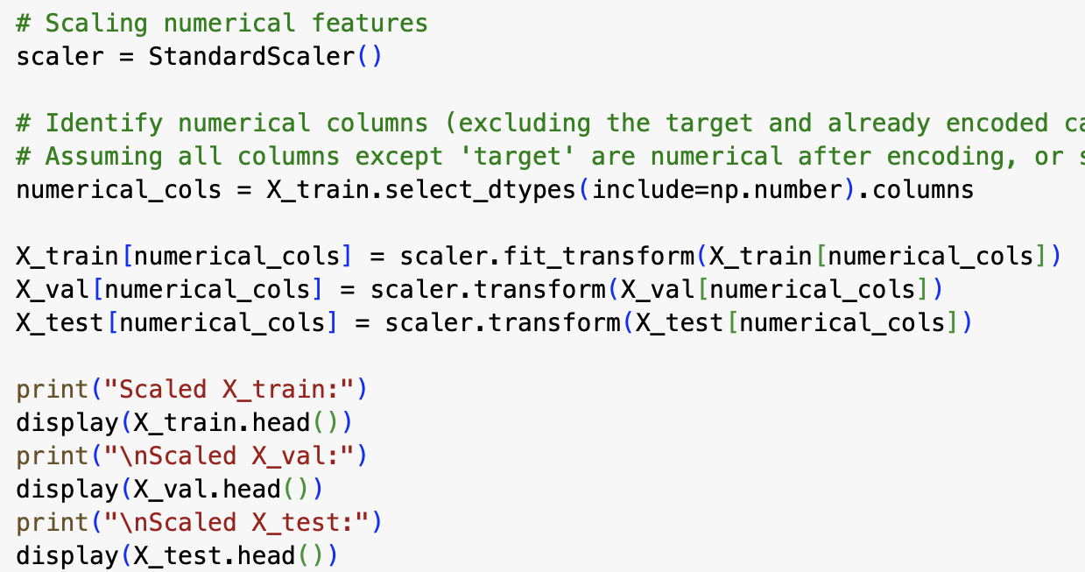

Table:
Algorithm | Hyper-parameter | Description | Value
Logistic Regression | C | The inverse of the strength of regularization (smaller values means stronger regularizarion) | 10
 | penalty | This is about the type of the regularization that is applied | l2
 | solver | Algorithm used for optimization | liblinear
Decision Tree | criterion | This is thefunction that is used to measure the qualuty of a split | gini
 | Max depth | This is rhe maximum depth of the tree; none means the nodes expanded until theyre pure | None
 | Min samples leaf | This is the least or minimum amiunt of samples required at a leaf node | 1
 | Min samples split | Least or minimum amount of samples required to split an internal node | 2
Random Forest | bootstrap | This shows wether boot strap samples are used when building trees | True
 | Max depth | This is rhe maximum depth of the tree; none means the nodes expanded until theyre pure | None
 | Min samples leaf | This is the least or minimum amiunt of samples required at a leaf node | 1
 | Min samples split | Least or minimum amount of samples required to split an internal node | 2
 | n_estimators | Number of trees in the forest | 300
Support Vector Machine (SVM) | C | Parameter for regularization (higher values = less regularization) | 10
 | gamma | Kernel coefficient (scale = 1 / (n_features × X.var)) | scale
 | kernel | Kernel type specifying the decision boundary | rbf

We trained four models: Logistic Regression, Decision Tree, Random Forest, and Support Vector Machine (SVM). Each model works in a different way. Logistic Regression is simple and uses probabilities. A Decision Tree makes step-by-step rules. Random Forest builds many trees and combines them for better accuracy. SVM finds the best line or curve that separates the classes. For each model, we tested different settings, called hyperparameters, to find the best ones. Logistic Regression worked best with C=10, penalty=l2, and solver=liblinear. The Decision Tree worked best with criterion=gini, max_depth=None, min_samples_split=2, and min_samples_leaf=1. The Random Forest gave the best results with 300 trees, max_depth=None, min_samples_split=2, min_samples_leaf=1, and bootstrap=True. The SVM worked best with C=10, kernel=rbf, and gamma=scale. We used GridSearchCV and cross-validation to test these options and choose the settings that gave the best balance of accuracy and generalization.

PART-5 in template:
Model Evaluation
1.
To check how good our models were, we used Accuracy, Precision, Recall, F1-score, and ROC-AUC.
- Accuracy tells us the overall percentage of correct predictions.
- Precision shows how many of the predicted positives were actually correct.
- Recall shows how many real positives the model caught.
- F1-score balances precision and recall, which is important when both matter.
- ROC-AUC measures how well the model separates the classes across different thresholds.
We used these metrics because relying on only accuracy can be misleading, especially in medical problems where missing a positive case (heart disease) can be very harmful.

2.

We divided the dataset into three parts: training (70%), validation (15%), and test (15%).
- The training set was used to teach the models.
- The validation set was used to compare models and tune hyperparameters with GridSearchCV.
- After picking the best models, we tested them on the test set, which was kept separate until the end to give an unbiased check of performance.
This way, the test set acts like “new data” and helps us see how the model might perform in the real world.

3.
Our models are considered reliable when their training, validation, and test performances are close to each other. To make sure of this, we used a three-way split and also applied cross-validation while tuning the hyperparameters. This reduced the chance of random results and gave a fairer estimate of how the models might behave on new, unseen data. In simple terms: if the training accuracy is very high but the validation or test accuracy is much lower, the model is overfitting. If both training and validation accuracies are low, it is underfitting. If the scores are similar and good on all sets, then the model is well-balanced and reliable.
- Logistic Regression: This model is simple and usually stable. In our case, it performed consistently across training, validation, and test sets, but the scores were not as high as the more complex models. This shows it is slightly underfitting because it cannot capture all the complex patterns in the data. However, it is still valuable because of its simplicity and interpretability.
- Decision Tree: With no maximum depth, the tree kept growing and fit the training data very closely. This caused very high training accuracy but lower validation accuracy, which is a clear sign of overfitting. It means the tree learned the training data almost perfectly but may not perform as well on new data.
- Random Forest: By combining many trees, Random Forest reduced the overfitting problem of a single tree. Its training and validation scores were both high and close to each other. This shows it is well-balanced and generalizes better than a single Decision Tree. However, the perfect scores suggest it may still be overfitting slightly because of the small dataset.
- Support Vector Machine (SVM): With the chosen parameters (C=10, rbf kernel, gamma=scale), the SVM performed strongly and did not show large gaps between training, validation, and test sets. This means it is also well-balanced. It gave high recall, which is very important in a medical problem like heart disease because it reduces the risk of missing positive cases.
Overall, the results show that Logistic Regression is stable but underfits, Decision Tree is clear but overfits, Random Forest is strong but may be slightly overfitting, and SVM is the most balanced and reliable option. This makes SVM the most suitable model for this project.
Among all the models tested, SVM proved to be the most suitable for this project. Unlike Logistic Regression, which underfit the data, and Decision Tree or Random Forest, which showed signs of overfitting, SVM achieved strong and balanced performance on training, validation, and test sets. Its accuracy was above 90% and its F1-score remained high across different splits, showing that it generalizes well and is not just memorizing the data. Most importantly, SVM also had a very high recall, meaning it correctly identified most patients with heart disease. This is especially valuable in healthcare, where missing positive cases can be very harmful. For these reasons, SVM is the most reliable and practical choice among the models we trained.
While Decision Tree and Random Forest achieved high performance, their tendency to overfit makes them risky for deployment in real-world medical contexts. End-users such as doctors need models that generalize well to unseen patients, not just those in the training dataset. More importantly, in heart disease prediction, the cost of a false negative (failing to detect a patient with disease) is much higher than a false positive. SVM’s high recall directly addresses this requirement, as it minimizes missed cases. This makes SVM not only technically accurate but also aligned with the practical needs of healthcare professionals and patients.

4.

The results from both the validation and test sets show clear differences between the models. Logistic Regression achieved stable but modest performance, with an accuracy of around 83-84% and an F1-score of 0.84. This indicates that while it is reliable, it struggles to capture complex patterns in the data, leading to slight underfitting.
The Decision Tree model performed extremely well, with accuracy close to 99% and an F1-score of 0.986 on both validation and test sets. However, because the tree was allowed to grow without depth limits, it is likely memorizing the data. This very high score suggests the model is overfitting, which means it may not generalize as well to unseen data.
The Random Forest gave perfect scores (accuracy, precision, recall, F1, and AUC all equal to 1.000) on both validation and test sets. While this makes it the strongest model in terms of numbers, it is highly unusual to achieve such perfection. This raises concerns that the model might be overfitting, especially given the relatively small dataset size.
The Support Vector Machine (SVM) showed strong and consistent results, with validation accuracy of 93% and test accuracy of 91%. Its recall of 0.954 means it correctly identified almost all patients with heart disease, which is very important in healthcare. Unlike Random Forest and Decision Tree, the SVM did not give “too perfect” scores, suggesting that it is more balanced and realistic in its performance.
Overall, the analysis suggests that SVM is the most effective and balanced model in this case. Logistic Regression is stable but weaker due to underfitting. Decision Tree and Random Forest achieved excellent scores but are most likely overfitting to the dataset. For practical use, SVM appears to offer the best balance between accuracy, recall, and generalization.

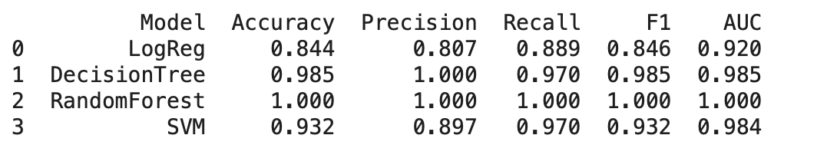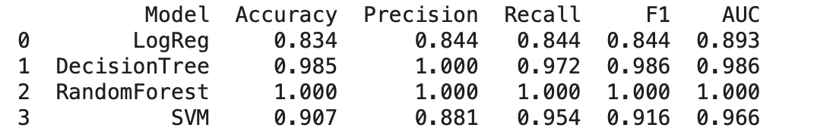
(you can view them more clearly and distinguish which one is for validation and which one is for testing in the code)

5.

Logistic Regression
  - Strengths: Simple, fast, easy to explain, gives probabilities
  - Strengths: Works well when the relationship between variables is mostly linear
  - Weaknesses: Too simple, can miss complex patterns (underfitting)
  - Weaknesses: Performance drops when features are strongly correlated or non-linear
Decision Tree
  - Strengths: Easy to understand, easy to visualize, learns clear rules
  - Strengths: Can handle both numerical and categorical data without much preprocessing
  - Weaknesses: Can overfit and memorize data if not limited
  - Weaknesses: Small changes in data can change the whole tree (unstable)
Random Forest
  - Strengths: More accurate and stable than a single tree, handles complex data well
  - Strengths: Reduces overfitting by averaging many trees
  - Weaknesses: Harder to explain, can still overfit on small datasets
  - Weaknesses: Requires more time and resources to train compared to single models
Support Vector Machine (SVM)
  - Strengths: Very good at finding complex patterns, strong and balanced results
  - Strengths: Works well in high-dimensional spaces where other models may struggle
  - Weaknesses: Slower to train, harder to explain, needs careful tuning
  - Weaknesses: Choice of kernel and parameters can greatly affect performance
Overall, each model has its pros and cons. Logistic Regression is simple but limited, Decision Tree is clear but overfits, Random Forest is powerful but complex, and SVM is accurate but harder to tune. Among them, SVM and Random Forest gave the best balance of results, making them the most effective for this project.

6.

This project has a few important limitations. The dataset was fairly small, with just over 1,000 records, which limits how well the models can learn general patterns. With such a small dataset, some models, like the Decision Tree and Random Forest, reached almost perfect scores, which is a sign of overfitting because the models may have memorized the data instead of truly learning from it. Logistic Regression, on the other hand, was too simple and showed lower scores, which suggests underfitting as it could not capture enough detail in the data. Another limitation is that we only worked with a set of common machine learning models, which means there could be other approaches that perform differently but were not tested. We also did not add many new features or transformations, so the models were limited to the information already present in the dataset.
For future improvement, the project could benefit from using more data, which would help the models generalize better and reduce the risk of overfitting. It would also help to try more variations of the models, adjust hyperparameters in greater detail, and test additional models to compare performance. Improving preprocessing, such as refining how features are scaled or encoded, could also make the models more accurate. Overall, the results are promising, but more data and careful tuning are needed to make the models stronger and more reliable.

Table:
Combination of hyperparameter values | Training performance (Accuracy, F1) | Validation performance (Accuracy, F1)
Logistic Regression (C=10, penalty=l2, solver=liblinear) | Accuracy: 0.839, F1: 0.847 | Accuracy: 0.844, F1: 0.846
Decision Tree (criterion=gini, max_depth=None, min_samples_split=2, min_samples_leaf=1) | Accuracy : 1.000, F1: 1.000 | Accuracy: 0.985, F1: 0.986
Random Forest (n_estimators=300, max_depth=None, min_samples_split=2, min_samples_leaf=1, bootstrap=True) | Accuracy: 1.000, F1: 1.000 | Accuracy: 1.000, F1: 1.000
SVM (C=10, kernel=rbf, gamma=scale) | Accuracy: 0.950, F1: 0.952 | Accuracy: 0.932, F1: 0.932

The table shows the best hyperparameters for each model along with their training and validation performance. Logistic Regression had lower scores, showing some underfitting. Decision Tree and Random Forest scored perfectly on training, which means they overfitted, although Random Forest also kept very high validation results. SVM gave high and balanced scores on both training and validation, making it the most reliable model overall.

REFERENCES

POWERPOINT SLIDES
https://www.google.com/url?sa=t&source=web&rct=j&opi=89978449&url=https://stackoverflow.com/questions/19335165/what-is-the-difference-between-cross-validation-and-grid-search&ved=2ahUKEwj3gt_ExcePAxXLRPEDHS5jM4QQFnoECBoQAQ&usg=AOvVaw1Nv5cwFCwEtpVbMx8zbOxb

https://www.google.com/url?sa=t&source=web&rct=j&opi=89978449&url=https://www.geeksforgeeks.org/machine-learning/understanding-logistic-regression/&ved=2ahUKEwim7cbpyMePAxUeRvEDHSrtCzIQFnoECDEQAQ&usg=AOvVaw14AVKDWoHhN44-R4oBgGYn

https://www.google.com/url?sa=t&source=web&rct=j&opi=89978449&url=https://scikit-learn.org/stable/modules/cross_validation.html&ved=2ahUKEwitwtHxyMePAxVGQ_EDHbKpPM4QFnoECC4QAQ&usg=AOvVaw2vyflgocMSjkZrx0g38B93
https://www.google.com/url?sa=t&source=web&rct=j&opi=89978449&url=https://scikit-learn.org/stable/modules/svm.html&ved=2ahUKEwjykJj1yMePAxUMSvEDHZkBCRkQFnoECCoQAQ&usg=AOvVaw3d1ocGqrq44EI4CP_Ggced

https://www.google.com/url?sa=t&source=web&rct=j&opi=89978449&url=https://medium.com/codex/decision-tree-for-classification-entropy-and-information-gain-cd9f99a26e0d&ved=2ahUKEwjblOP5yMePAxUsSPEDHRINEksQFnoECBkQAQ&usg=AOvVaw35Sqn8xHK047TkFoR0dJAb

https://www.google.com/url?sa=t&source=web&rct=j&opi=89978449&url=https://www.w3schools.com/python/python_ml_decision_tree.asp&ved=2ahUKEwjandX-yMePAxXtc_EDHQY-M8MQFnoECDIQAQ&usg=AOvVaw2YHtv0S-IK7whgbKlwtIyo

